# MCQ

1 What will be the output of the following code snippet?

# def func(a, b):

**return b if a == 0 else func(b % a, a) print(func(30, 75))**

# 10

1. **20**

# 15

1. **0**

Ans. A

# 2 numbers = (4, 7, 19, 2, 89, 45, 72, 22)

**sorted_numbers = sorted(numbers) even = lambda a: a % 2 == 0**

# even_numbers = filter(even, sorted_numbers) print(type(even_numbers))

1. **Int**

# Filter

1. **List**

# Tuple

Ans. B

1. As what datatype are the *args stored, when passed into
   1. Tuple
   2. List
   3. Dictionary
   4. none

Ans. A

# 4) set1 = {14, 3, 55}

**set2 = {82, 49, 62} set3={99,22,17}**

# print(len(set1 + set2 + set3))

**a) 105**

# b) 270

* + 1. **0**

# Error

Ans. D

1. What keyword is used in Python to raise exceptions?
   1. raise
   2. try
   3. goto
   4. except

Ans. A

1. Which of the following modules need to be imported to handle date time computations in Python?
   1. timedate
   2. date
   3. datetime
   4. time

Ans. C

1. What will be the output of the following code snippet?

# print(4**3 + (7 + 5)**(1 + 1)) a) 248

**b) 169**

# c) 208

**d) 233**

Ans. C

1. Which of the following functions converts date to corresponding time in Python?
   1. strptime
   2. strftime
   3. both a) and b)
   4. None

Ans. A

1. The python tuple is in nature.
   1. mutable b)immutable
2. unchangeable
3. none

Ans. B

1. The is a built-in function that returns a range object that consists series of integer numbers, which we can iterate using a for loop.
2. range()
3. set()
4. dictionary{}
5. None of the mentioned above

Ans. A

# Question 11

**Amongst which of the following is a function which does not have any name?**

1. Del function
2. Show function
3. Lambda function
4. None of the mentioned above

Ans. D

Question 12

# The module Pickle is used to .

1. Serializing Python object structure
2. De-serializing Python object structure
3. Both A and B
4. None of the mentioned above

Ans. C

Question 13

# Amongst which of the following is / are the method of convert Python objects for writing data in a binary file?

1. set() method
2. dump() method
3. load() method
4. None of the mentioned above

Ans. B

# 14) Amongst which of the following is / are the method used to unpickling data from a binary file?

1. load()
2. set() method
3. dump() method
4. None of the mentioned above

Ans. A

15) A text file contains only textual information consisting of .

1. Alphabets
2. Numbers
3. Special symbols
4. All of the mentioned above

Ans. D

16) Which Python code could replace the ellipsis (...) below to get the following output? (Select all that apply.)

captains = { "Enterprise": "Picard",

"Voyager": "Janeway", "Defiant": "Sisko",

}

Enterprise Picard,

Voyager Janeway

Defiant Sisko

* 1. for ship, captain in captains.items(): print(ship, captain)
  2. for ship in captains: print(ship, captains[ship])
  3. for ship in captains:

print(ship, captains)

* 1. both a and b

Ans. A

# 17) Which of the following lines of code will create an empty dictionary named captains?

* 1. captains = {dict}
  2. type(captains)
  3. captains.dict()
  4. captains = {}

Ans. D

1. Now you have your empty dictionary named captains. It’s time to add some data!

Specifically, you want to add the key-value pairs "Enterprise": "Picard", "Voyager": "Janeway", and "Defiant": "Sisko".

Which of the following code snippets will successfully add these key-value pairs to the existing captains dictionary?

* 1. captains{"Enterprise" = "Picard"} captains{"Voyager" = "Janeway"} captains{"Defiant" = "Sisko"}
  2. captains["Enterprise"] = "Picard" captains["Voyager"] = "Janeway" captains["Defiant"] = "Sisko"
  3. captains = { "Enterprise": "Picard", "Voyager": "Janeway", "Defiant": "Sisko",

}

* 1. None of the above

Ans. C

**19 )** You’re really building out the Federation Starfleet now! Here’s what you have:

captains = {

"Enterprise": "Picard",

"Voyager": "Janeway",

"Defiant": "Sisko",

"Discovery": "unknown",

}Now, say you want to display the ship and captain names contained in the dictionary, but you also want to provide some additional context. How could you do it?

1. for item in captains.items():

print(f"The [ship] is captained by [captain].")

1. for ship, captain in captains.items(): print(f"The {ship} is captained by {captain}.")
2. for captain, ship in captains.items(): print(f"The {ship} is captained by {captain}.")
3. All are correct

Ans. D

# 20 )

You’ve created a dictionary, added data, checked for the existence of keys, and iterated over it with a for loop. Now you’re ready to delete a key from this dictionary:

captains = {

"Enterprise": "Picard",

"Voyager": "Janeway",

"Defiant": "Sisko",

"Discovery": "unknown",

}

What statement will remove the entry for the key "Discovery"?

1. del captains
2. captains.remove()
3. del captains["Discovery"]
4. captains["Discovery"].pop()

Ans. C

21 When implementing linear regression of some dependent variable 𝑦 on the set of independent variables 𝐱 = (𝑥₁, …, 𝑥ᵣ), where 𝑟 is the number of predictors, which of the following statements will be true?

1. 𝛽₀, 𝛽₁, …, 𝛽ᵣ are the **regression coefficients**.
2. Linear regression is about determining the **best predicted weights** by using the **method of ordinary least squares**.
3. E is the random interval
4. Both and b

Ans. A

22 )

What indicates that you have a **perfect fit** in linear regression?

1. The value 𝑅² < 1, which corresponds to SSR = 0
2. The value 𝑅² = 0, which corresponds to SSR = 1
3. The value 𝑅² > 0, which corresponds to SSR = 1
4. The value 𝑅² = 1, which corresponds to SSR = 0

Ans. A

23)

In simple linear regression, the value of **what** shows the point where the estimated regression line crosses the 𝑦 axis?

1. Y
2. B0
3. B1
4. F

Ans. A

24)

Check out these four linear regression plots:

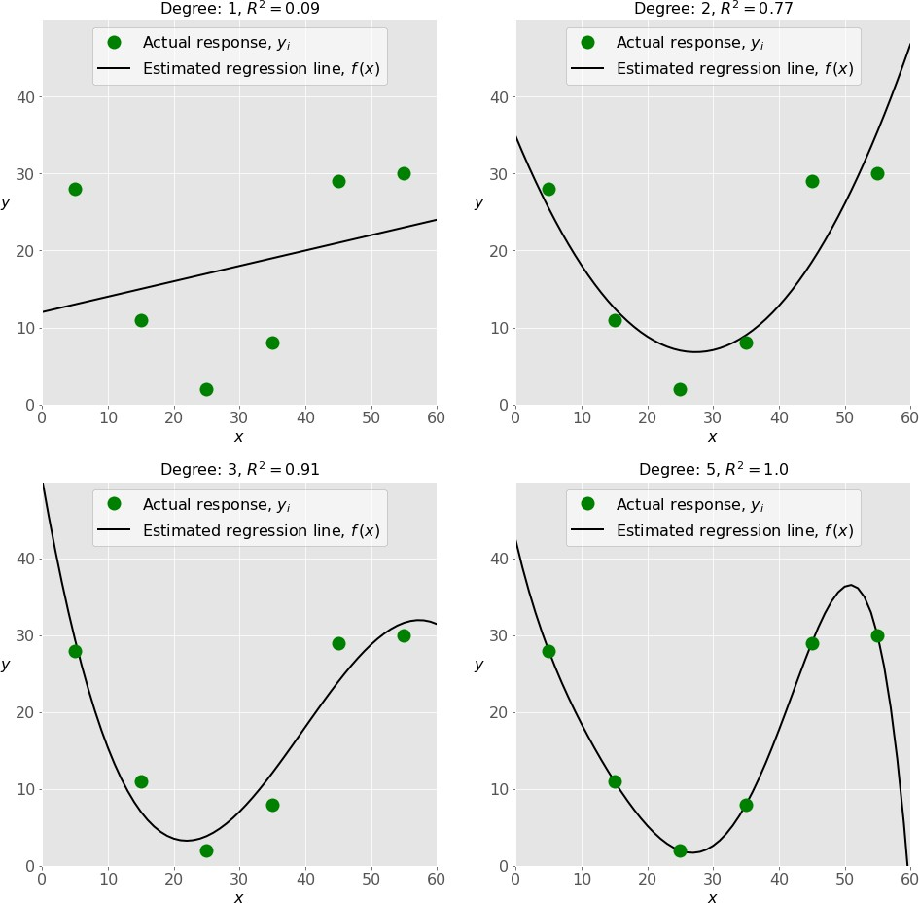

Which one represents an **underfitted** model?

1. The bottom-left plot
2. The top-right plot
3. The bottom-right plot
4. The top-left plot

Ans. D

25)

There are five basic steps when you’re implementing linear regression:

* + **a.** Check the results of model fitting to know whether the model is satisfactory.
  + **b.** Provide data to work with, and eventually do appropriate transformations.
  + **c.** Apply the model for predictions.
  + **d.** Import the packages and classes that you need.
  + **e.** Create a regression model and fit it with existing data.

However, those steps are currently listed in the wrong order. What’s the correct order?

1. e, c, a, b, d
2. e, d, b, a, c
3. d, e, c, b, a
4. d, b, e, a, c

Ans. D

26 ) Which of the following are optional parameters to LinearRegression in scikit-learn?

1. Fit
2. fit_intercept
3. normalize
4. copy_X
5. n_jobs
6. reshape

Ans. B

1. While working with scikit-learn, in which type of regression do you need to transform the array of inputs to include nonlinear terms such as 𝑥²?
2. Multiple linear regression
3. Simple linear regression
4. Polynomial regression

Ans. C

1. You should choose statsmodels over scikit-learn when:

A)You want graphical representations of your data.

1. You’re working with nonlinear terms.
2. You need more detailed results.
3. You need to include optional parameters.

Ans. C

1. is a fundamental package for scientific computing with Python. It offers comprehensive mathematical functions, random number generators, linear algebra routines, Fourier transforms, and more. It provides a high-level syntax that makes it accessible and productive.
2. Pandas
3. Numpy
4. Statsmodel
5. scipy

Ans. B

30 ) is a Python data visualization library based on Matplotlib. It provides a high-level interface for drawing attractive and informative statistical graphics that allow you to explore and understand your data. It integrates closely with pandas data structures.

1. Bokeh
2. Seaborn
3. Matplotlib
4. Dash

Ans. B